Portrait Picker
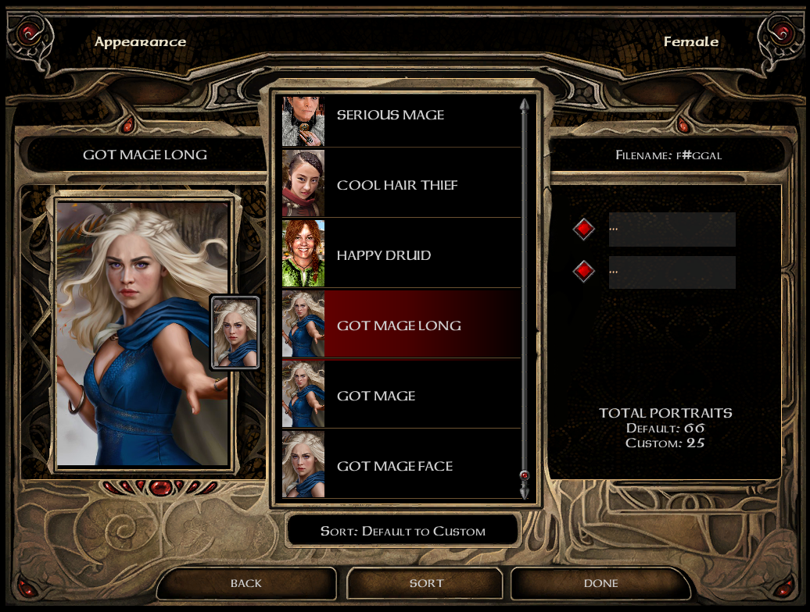
Instructions
Compatible with v2.1+ of BG2EE

By Mr2150
Getting Started

You will need:
- BG2EE
- A selection of custom portraits
- A text editor
(I use Notepad++ which is available for free)
- Some Time

Please Note:
The Portrait Picker has worked successfully for 200+ portraits although some people have encountered issues when using the MOD (usually crashing to desktop).
These issues relate to the filename or image type/quality and can be resolved by checking your files for compatibility during the process of registering your portraits.
Portrait Picker currently supports a variety of languages.

SPECIAL THANKS GO TO:
Italian Translation - @Aedan
Polish Translation - @Cahir
German Translation - @Hurricane
Czech Translation - @Edvin
Brazilian Portuguese Translation - @Nasher
French Translation - @Isaya
@AncientCowboy for advice and suggestions
@Pecca for advice, suggestions, graphics and WEIDU support
For testing and sugestions: @smeagolheart, @lefreut, @sids118, @Pecca, @Aedan
KNOWN COMPATIBILITIES:
Lefreut’s excellent [Mod] Restore Missing Portrait (BG1EE/SOD/BG2EE) – CONFIRMED
This mod restores missing portraits and ensures that all games have access to the same Default portrait pool.
- Install the mod as per the instructions and ensure that the M_port.lua file he provides is in your override directory with the new portraits.
- All additional portraits have already been incorportated into the M_nicks.lua file allowing you to apply your own descriptions.
- If you do not install this mod, it will NOT impact the function of the portait picker.

My Random Character Generation Mini-Mod - CONFIRMED
This mod allows you to generate a random character instead of rolling manually.
- Install the mod as per the instructions.
- If you do not install this mod, it will NOT impact the function of the portait picker.

STAGE 1 – Editing UI.Menu
- If you have not edited the UI.menu previously then you can skip all of Stage 1 and copy the UI.menu file from the Other Files folder to your override.
Otherwise, - backup your current UI.menu from your override folder so if things do go wrong you can easily revert back to the previous version. I call my backup UI.menu-backup

- If you do not have a UI.menu file in your override folder then follow the instructions here regarding UI Edit Mode and the F11 key and then backup:
https://forums.beamdog.com/discussion/comment/723397/

- Open UI.menu in your text editor.

If you are using v2.2 of BG2EE
you should skip ahead to point (7) and ignore points (5) and (6).

- At the start of the file you will see the following code:
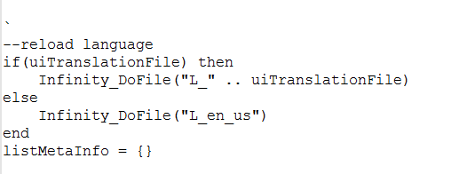
- Type the following three lines underneath listMetaInfo = {}
Infinity_DoFile("M_BG")
Infinity_DoFile("M_nicks")
Infinity_DoFIle("M_PPxxYY")
where xxYY is your language choice.

- Your UI.menu should now look like this:
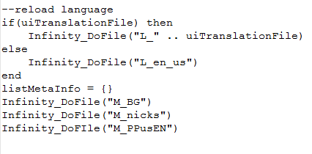
These lines allows the UI.menu to access a file called M_BG.lua which we will be creating in STAGE 3 as a database for the portraits, it also allows you to create nicknames for the default portraits in M_nicks.lua, and makes sure all the buttons/text are in the correct language.
- Open the relevant UI CHANGES text file for the game you wish to modify (found in UI Changes folder).

- Press Ctrl + A and then Ctrl + C to copy all of the text.

- Now go back to UI.menu and press CTRL + F and search for CHARGEN_PORTRAIT

- You should see some code that looks like this:
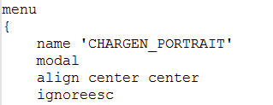
This is the menu for character generation portrait selection. We need to edit this menu to enable the new functionality.
- Highlight from and including the word menu all the way down up to and including the following code:

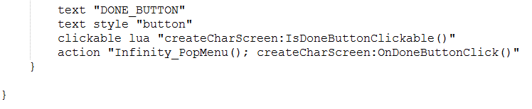
Don’t forget to highlight the two closing curly brackets on the end!

- Press Ctrl + V to paste all of the new code in.

- Now save the UI.menu and close it.

- Now copy the following three files to your override folder:
- BWGUIBA.png (found in common files folder)
- M_nicks.lua (found in common files folder)
- NOPORTMD.BMP (found in common files folder)
- RGGUIBA.png (found in common files folder)
- M_PPxxYY.lua (where xxYY is your language selection – found in language folder)

- If you load the game now you should see the following screens when you get to the Portrait page of character generation:
BG2EE
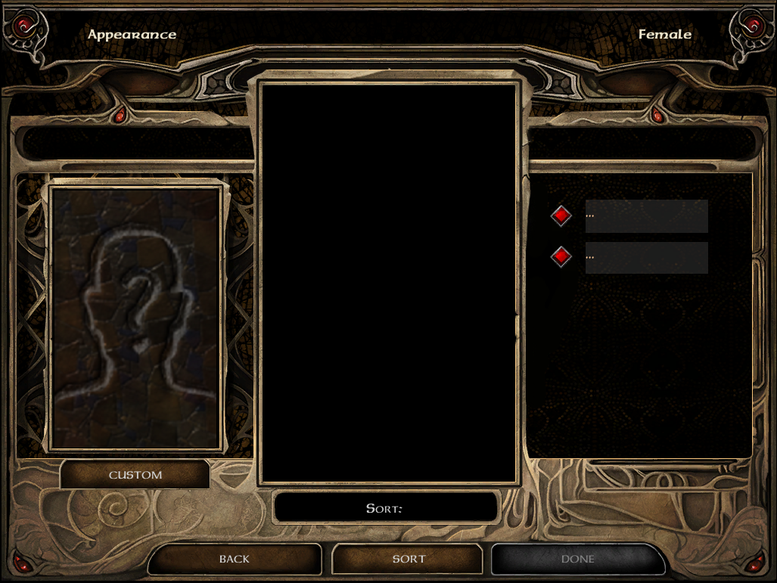
If your screen matches the image here then we are done editing the UI.menu – so save and close the file.
If you get an error or crash then you may need to restore your backup UI.menu and start-over.
STAGE 2 – Preparing Your Portraits

- First go to:
https://forums.beamdog.com/discussion/53744/custom-portrait-problems-after-update and read the thread.
As you will see v2 and later versions of BGEE and BG2EE apparently made some changes to the way portraits are handled. Previous rules have changed a little so this stage will try to fix any likely errors before they happen and if you follow this stage carefully it’s very likely all your portraits will work fine…
- Based on experience the following compliancy rules should be used:
- Portraits should be 24-bit BMP files with dimensions no greater than 1024 pixels (width or height) and the overall image size should be no greater than 1MB.
- Portrait filenames should not exceed 7 characters.
- Portrait filenames must be lowercase and not end in -l/ -m/ -s.
- However, if you want to use two images together but have one display in the record screen and the other display in the sidebar, then please rename the files to add an uppercase -L to the end of the image filename for the record screen and -M for the image filename to display on the sidebar, taking care to ensure that the rest of the filename is identical. The L and M *are* included in the character limit of 7 letters (** see optimal setup)
- If you do include a filename with -L then you should include an identical filename with -M.
- If you want portraits to be identified as Male or Female on import then please make sure the filename begins m# or f# respectively.
- Filenames should not be the same or too similar to a potential existing portrait filename unless you want to replace an existing filename, eg coran* should be avoided. A list of these filenames can be found in NearInfinity by checking BGEE.lua
How to quickly make all portrait filenames lower case
Open a command prompt (START > RUN > type CMD, press enter) and go to the directory that has your portraits.
This is usually in the game folder found in your My Documents folder.
(to do this, you may need to get the full path from Windows Explorer, and then type 'cd <your path name>' into the command prompt). Like this:
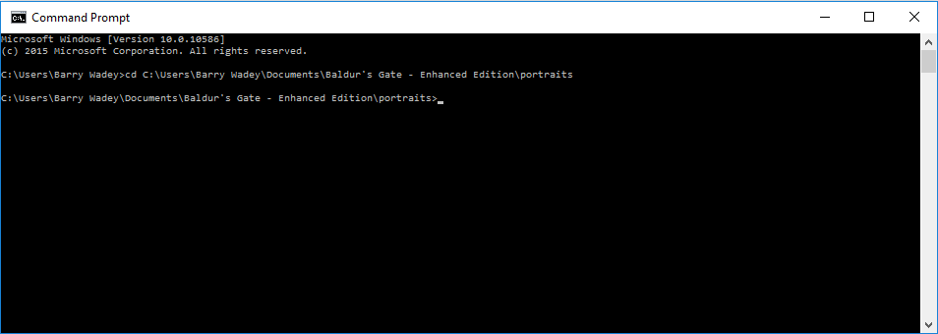
Now enter the following code into the command prompt window, making sure to copy it exactly.
for /f "Tokens=*" %f in ('dir /l/b/a-d') do (rename "%f" "%f")
and then press return. In a Windows Explorer window verify that the filenames have converted to lowercase.
Optimal Setup for -L and -M portraits
The Portrait Picker supports multiple versions of the same portrait.
If you have two portraits that are the same character but want to sometimes use them separately and sometimes together (with one on the sidebar and the other in the character record screen), here is the recommended naming convention and setup:
Portrait 1 filename = xxxx = long shot
Portrait 2 filename = yyyy = face shot
OPTIMAL SETUP:
Copy both portraits to your portrait folder TWICE. Rename them as follows:
Portrait 1 original 'xxxx' => renamed to zzzzaL
Portrait 1 copy 'xxxx - copy' => renamed to zzzzb
Portrait 2 original 'yyyy' => renamed to zzzzaM
Portrait 2 copy 'yyyy - copy'=> renamed to zzzzc
Portraits zzzzaL, zzzzb and zzzzc will appear in the portrait picker and can be picked individually, if you pick zzzzaL will be used in the character screen then zzzzaM will be used in the sidebar. If you are using zzzzaL or zzzzaM naming then you should avoid calling other portraits zzzza as this will cause a conflict and crash the portrait picker.
Example:
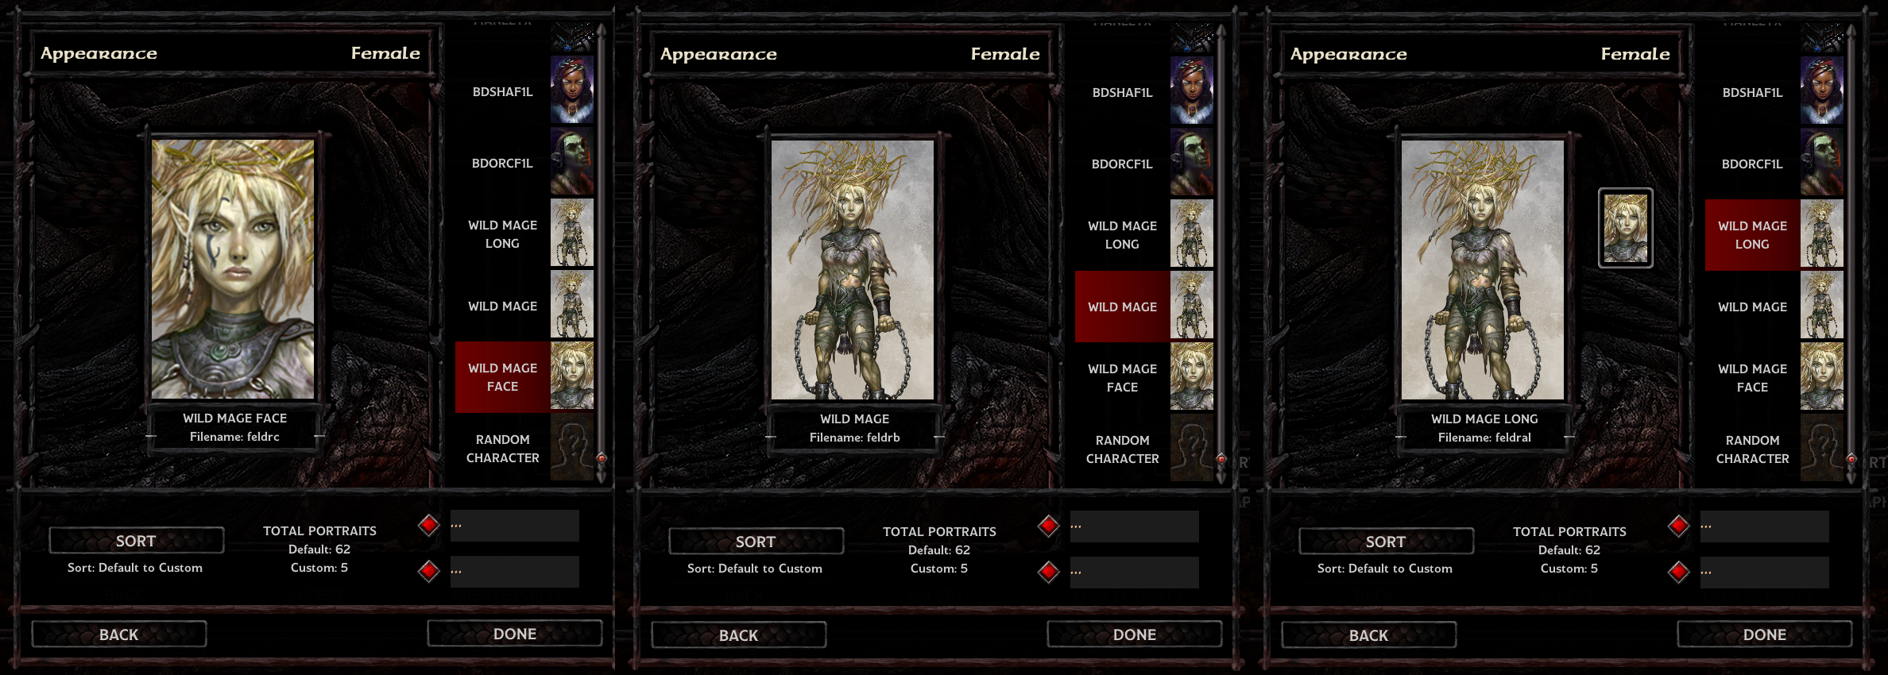
STAGE 3 – Registering Your Portraits In M_BG.lua

Copy the contents of the WEIDU folder to your game folder (the same folder with SiegeOfDragonspear.exe in it). It should look something like this:
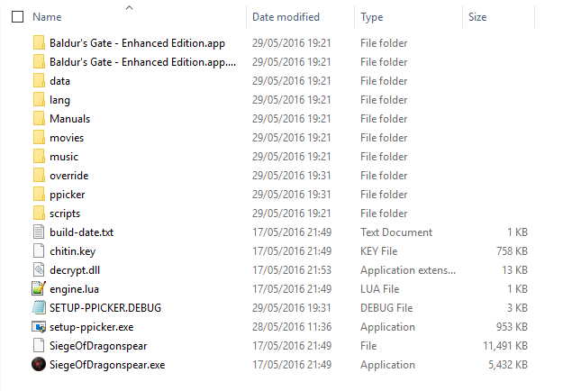
Double-click on setup-ppicker.exe to run the installer. Select your language and then click install.
REMEMBER – ANY TIME YOU MAKE CHANGES TO THE PORTRAITS YOU WILL NEED TO REPEAT THE SETUP AGAIN TO REGISTER THE NEW PORTRAIT FILES.
The Setup will offer to backup your existing M_BG.lua file if you have one – choose I to install the backup.
You can open the M_BG.lua file from your override and manually edit the Description (1st column) and Gender (2nd Column) of the M_BG.lua file at any time.
There are four possible choices for Gender: M, F, D (appears in Male/Female lists) and Z (does not appear in either list).
Troubleshooting
If you are experiencing any issues/crashes when selecting certain portraits or scrolling then you should set the gender to Z for the problematic portraits whilst you investigate the reason – this will let you use the portrait picker whilst you try to resolve.
Once you’ve resolved the filename, delete the old filename line from the M_BG.lua and re-run the setup to reinstall the portrait. The most likely cause will be the filename so check the compliancy rules again.

